|  |  |  |  |  |  |
| --- | --- | --- | --- | --- | --- |
| AIUB | | **American International University-Bangladesh (AIUB)**  **Faculty of Engineering (FE)**  **Department of Electrical and Electronic Engineering (EEE)** | | | |
|  | | |  |  |  | |
| **Course Name:** | | | Microprocessor and Embedded Systems | **Course Code:** | EEE 4103 | |
| **Semester:** | | | Fall 2023-2024 | **Section:** | O | |
| **Faculty Name:** | | | **Protik Parvez Sheikh** | | | |
|  | | |  |  |  | |
| **Capstone Project Title:** | | | Smart Soil Moisture Management System with Automated Watering | | | |
| **Project Group #:** | | | 04 | | | |
|  | | |  |  |  | |
| **SL #** | **Student Name** | | | **Student ID #** | | |
| **1.** | **Md. Jobaer Hossain** | | | **22-47116-1** | | |
| **2.** | **Samia Sharmin Dola** | | | **22-47126-1** | | |
| **3.** | **Md. Samin Yeasar** | | | **22-47139-1** | | |
| **4.** | **Rifah Sanzida** | | | **22-47154-1** | | |
| **5.** | **Shayan Abrar** | | | **22-47156-1** | | |

***Assessment Materials and Marks Allocation:***

|  |  |  |  |  |  |  |  |  |
| --- | --- | --- | --- | --- | --- | --- | --- | --- |
| **CO/**  **CLO Number** | **CO/CLO Statement** | **K** | **P** | **A** | **Assessed Program Outcome Indicator** | **BNQF Indicator** | **Teaching-Learning Strategy** | **Assessment Strategy** |
| **3** | **Demonstrate** a course project using microcontrollers, sensors, actuators, switches, display devices, etc. that can solve a complex engineering problem in the electrical and electronic engineering discipline through appropriate research. | **K8** | **P1**  **P3**  **P7** |  | **P.d.1.P3** | **FS.3** | **Discussion** | **Project Report (Literature Review)** |
| **4** | **Explain** the complex engineering activities of a course project solving a complex engineering problem of the electrical and electronic engineering discipline through an effective presentation. |  |  | **A1**  **A2** | **P.j.3.A4** | **SS.2** | **Discussion** | **Project Presentation** |

***Assessment Rubrics:***

|  |  |  |  |  |  |  |
| --- | --- | --- | --- | --- | --- | --- |
| **COs** | **Excellent to Proficient [5-4]** | **Good [3]** | **Acceptable [2]** | **Unacceptable [1]** | **No Response [0]** | **Secured Marks** |
| **CO3**  **P.d.1.P3** | The outcome of the project demonstrates a course project using microcontrollers, sensors, actuators, switches, display devices, etc. that can solve a complex engineering problem in the electrical and electronic engineering discipline through appropriate research. | The outcome of the project somewhat demonstrates a course project using microcontrollers, sensors, actuators, switches, display devices, etc., and also somewhat solves a complex engineering problem in the electrical and electronic engineering discipline through some research. | The outcome of the project demonstrates a course project using microcontrollers, sensors, actuators, switches, display devices, etc. but cannot solve a complex engineering problem properly in the electrical and electronic engineering discipline through appropriate research. | The outcome of the project does not demonstrate a course project using microcontrollers, sensors, actuators, switches, display devices, etc. also could not solve a complex engineering problem in the electrical and electronic engineering discipline through appropriate research. | No Response at all/copied from others/ identical submissions with gross errors/image file printed |  |
| **Comments** |  | | | | **Total Marks (5)** |  |

Smart Soil Moisture Management System with Automated Watering

Md. Jobaer Hossain, Samia Sharmin Dola, Md. Samin Yeasar, Rifah Sanzida and Shayan Abrar

[1]

*Abstract*— In contemporary agriculture, technology assumes a pivotal role, with automation emerging as a key enabler for executing procedures and processes devoid of direct human intervention. This study endeavors to elucidate the economic feasibility of employing an automated soil moisture system by individuals. A sensor-based automatic irrigation system, devised and implemented as a widely embraced and beneficial technology, represents a focal point in this exploration. The primary aim is to enhance efficiency in daily activities, easing the burden of time and labor for users. The proposed system integrates sensor technology with a microcontroller, relay, and water pump, functioning as an intelligent switching mechanism capable of discerning soil moisture levels and dispensing water to plants as needed. The water pump’s activation is contingent upon the soil's dryness level, facilitating an automated ON/OFF mechanism. Sensor readings are transmitted to the display through Arduino, generating visual representations for user awareness. This Arduino-controlled irrigation system finds versatile applications in both small and large-scale settings, including gardens, nurseries, greenhouses, and green roofs. The system not only optimizes resource usage but also streamlines the irrigation process for farmers, mitigating planning challenges. Consequently, the adoption of this automated approach not only contributes to time and energy savings but also minimizes water wastage, thereby enhancing overall agricultural efficiency and sustainability.

Keywords: Agriculture, Automation, Soil moister system, Arduino Uno, Sustainability.

# I. INTRODUCTION

Water is the lifeblood of our planet, and its efficient management is crucial for sustainable agriculture and a thriving ecosystem. Traditional irrigation practices, often reliant on manual scheduling or outdated sensors, lead to water waste and uneven distribution, impacting both plant health and resource conservation [1, 2]. This paper introduces a novel solution: a Smart Soil Moisture Management System with Automated Watering using Arduino Uno.

Our system leverages the power of the Arduino Uno microcontroller, a low-cost and versatile platform, to continuously monitor soil moisture levels through strategically placed sensors. This real-time data is then analyzed and used to trigger automated watering only when and where needed, mimicking nature's intelligent irrigation system. This approach eliminates overwatering, preventing waterlogging and disease, while ensuring optimal hydration for diverse plant needs [1, 4].

The Arduino Uno's programmability allows for customization and can be added additional features, such as:

* Scheduling and data logging: Set watering schedules based on plant types, weather conditions, and historical data [3].
* Remote control and monitoring: Access and manage the system remotely via smartphones or web interfaces, providing real-time insights into soil moisture levels and water usage [2].
* Integration with other sensors: Combine soil moisture data with temperature, light, and humidity readings for even more precise and adaptive watering decisions [5].

The objective of this project is to create a Smart Soil Moisture Management System to enhance agricultural practices in Bangladesh. The system aims to efficiently monitor real-time soil moisture levels and regulate irrigation accordingly, minimizing water wastage and promoting water conservation. Cultural and societal factors specific to Bangladesh will be considered during the design and implementation, to ensure seamless integration. The project emphasizes customization for the diverse range of crops in Bangladesh, aligning with their specific irrigation needs. Continuous monitoring, evaluation, and feedback mechanisms will be established to improve system performance over time. Cost-effectiveness for local farmers, environmental impact assessment, adherence to regulatory requirements, and community involvement through collaboration with local agricultural services are integral aspects of this comprehensive initiative.

In this study, following a comprehensive review of previous projects, we formulated a strategic plan for the development of a new irrigation system to achieve our objectives. Once the project outline was finalized, we meticulously selected an appropriate methodology and successfully executed the implementation in the field.

# II. Literature Review

The literature review encompasses a series of studies focusing on the integration of technology, particularly the Internet of Things (IoT), in agriculture, specifically addressing soil moisture management and irrigation systems. In the first study, IoT is highlighted as a transformative tool for farmers, providing real-time data on climate, moisture, temperature, and soil productivity, facilitating precision and functional farming through remote monitoring via sensors and cameras [6]. The second study emphasizes the development of an IoT-based solution, underscoring the significance of data collection, algorithm-driven actions, and a user-friendly interface for system configuration and monitoring [7]. The third study utilizes Arduino and soil moisture sensors to automate irrigation, presenting a system responsive to soil moisture levels, thereby enhancing water efficiency in agriculture [8]. Shifting focus in the fourth study, an Arduino-based plant irrigation system is designed to reduce costs and boost agricultural production through continuous monitoring and smart scheduling [9]. Lastly, the fifth study introduces an IoT and Wireless Sensor Network (WSN) integrated irrigation system, offering both automatic and manual operation with cloud-based monitoring through an Android application. This study also introduces new methods, including sensor node packaging, monitoring, manually watering processes using Virtuino, and a Wi-Fi routine checker using timer interrupt [10].

# III. Methodology

The methodology for this project revolves around achieving overarching aims and addressing specific objectives. The primary focus is on optimizing agricultural water use by developing a smart soil moisture management system, aiming to minimize water wastage and enhance irrigation efficiency. Additionally, the project seeks to improve crop yield and quality by maintaining optimal soil moisture levels, contributing to environmental sustainability by reducing the impact of irrigation practices. A user-friendly technology accessible to farmers in Bangladesh is a key objective, emphasizing cultural and societal integration. Objectives range from developing the system to customizing it for crop-specific management, ensuring water conservation, and evaluating its cost-effectiveness and environmental impact. The methodology places a strong emphasis on community involvement, information dissemination, and regulatory compliance, ensuring that the technology aligns with local needs and regulations while promoting sustainable agricultural practices.

The soil moisture sensor estimates soil moisture and transmits data to the Arduino Uno, which processes the information to determine the soil moisture level. When the moisture level falls below 30%, the RED LED illuminates, the Arduino activates the motor, and transmits data to the display, showcasing moisture level and motor status. If moisture exceeds 30%, the RED LED turns off, and the GREEN LED activates. The Arduino then deactivates the motor if running or maintains its state if off. The display provides real-time information on moisture percentage, soil condition (Dry or Normal), and motor status.

**Arduino Uno:** The Arduino Uno is a microcontroller board widely used in electronics and programming projects. Powered by the ATmega328P microcontroller, it features 14 digital input/output pins, six analog inputs, a USB connection for programming and power, and a 16 MHz crystal oscillator.

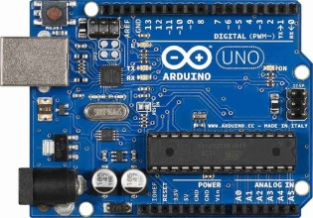

**Fig. 1.** Arduino Uno.

**Soil Moister Sensor:** The soil moisture sensor is a pivotal component in precision agriculture, designed to estimate the moisture content of soil. Employing advanced technology, it measures the water levels within the soil and translates this data into actionable insights. This sensor enables farmers and gardeners to optimize irrigation practices, ensuring efficient water usage and promoting healthier plant growth. Its accuracy and real-time data transmission empower users to make informed decisions, enhancing overall crop yield and sustainability.

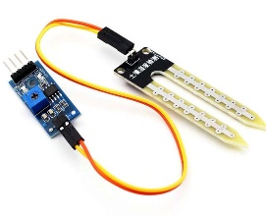

**Fig. 2.** Soil Moister Sensor.

**Mini Water Pump:** The 5V Mini Water Pump is a compact and efficient device designed for various water circulation applications. Operating on a 5-volt power supply, this miniature pump delivers reliable performance with low power consumption. Ideal for small-scale projects, aquariums, and DIY setups, it offers a steady water flow.

**Fig. 3.** 5V Mini Water Pump.

**OLED Display:** The OLED mini display is a compact, high-resolution screen that utilizes organic light-emitting diode technology to deliver vibrant and sharp visuals. With its small form factor, it is ideal for embedding in various electronic projects. Its self-illuminating pixels enable crisp text and vivid graphics, ensuring excellent readability.

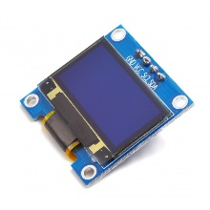

**Fig. 4.** OLED Display.

**5V Relay:** A 5V relay is an electromechanical switch designed for low-voltage applications, commonly interfaced with microcontrollers like Arduino. Operating on a 5-volt input, it serves as a control interface between the microcontroller and higher-voltage devices. When activated, the relay's internal switch closes, allowing or interrupting the flow of electrical current to connected devices.

**Fig. 5.** 5V Relay.

**LED:** Light Emitting Diodes (LEDs) are semiconductor devices that emit light when an electric current passes through them. These energy-efficient sources convert electrical energy into visible light, offering various colors and brightness levels. LEDs find widespread application in lighting due to their longevity, low power consumption, and compact design.

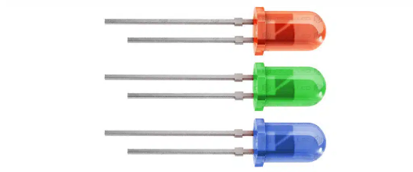

**Fig. 6.** LEDs.

In the presented experimental configuration, the soil moisture sensor is connected with the analog pin A0 of the Arduino Uno. The mini water pump, pivotal to the system's functionality, establishes connectivity with pin 5 via a 5V relay. The visual indicators, comprising a Green LED and a Red LED, are strategically linked to pins 4 and 7, respectively. Furthermore, the display interface seamlessly integrates with the Arduino Uno through the analog pins, fostering a cohesive and interconnected hardware system.

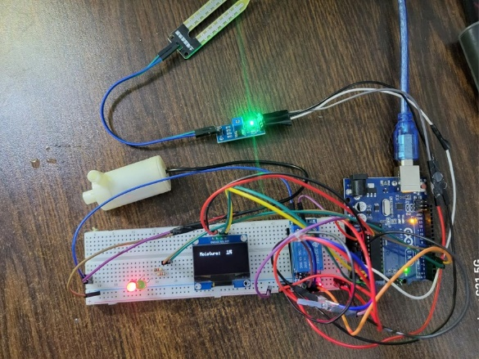

**Fig. 7.** Hardware setup.

# IV. Result and Discussion

## A. Simulation Results

In the simulation phase, we replicated the developed hardware circuits using Proteus 8.13, incorporating the same components and design principles. Utilizing a variable resistor in the simulation allowed us to emulate varying soil moisture levels. In this virtual environment, a resistor value below 30% signifies a corresponding soil moisture level below 30%. Due to software limitations, we substituted a DC motor for a water pump in the simulation.

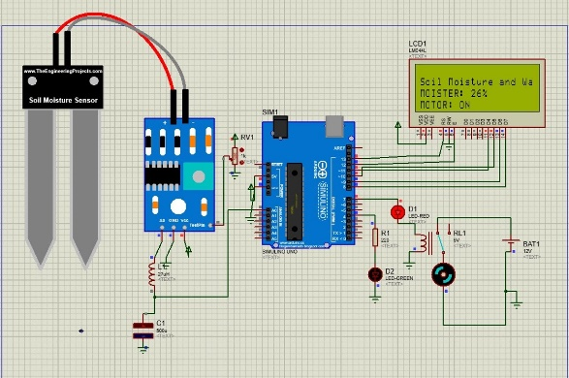

**Fig. 8.** Simulation result when the moisture level is less than 30%.

Just as in the hardware setup, the simulation employed identical code logic. When the simulated soil moisture fell below 30%, the RED LED illuminated, signaling the Arduino to activate the motor. Concurrently, relevant data was transmitted to the display, presenting real-time information on moisture levels and motor status. In instances where the moisture exceeded 30%, the RED LED turned off, triggering the activation of the GREEN LED. The Arduino responded by deactivating the motor if it was running or maintaining its current state if already off. The display continued to provide a comprehensive overview of moisture percentage, soil condition (Dry or Normal), and motor status, mirroring the real-world dynamics of soil moisture and system operation.

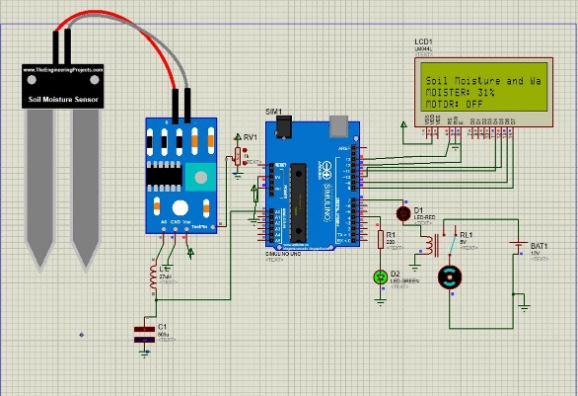

**Fig. 9.** Simulation result when the moisture level is greater than 30%.

## B. Experimental Results

Configuring the complete circuit for the soil moisture system and embedding the soil moisture sensor into the soil, the sensor promptly reads the data and transmits it to the Arduino. Subsequently, the Arduino processes this information, computes the moisture level, and displays the result. In scenarios where the moisture level falls below 30%, the Arduino not only activates the motor but also triggers the illumination of the RED LED. Conversely, if the moisture exceeds 30%, the RED LED deactivates, and the GREEN LED takes over. The Arduino takes appropriate action, either deactivating the motor if in operation or maintaining its current state if already off. The display consistently delivers real-time updates, presenting information on moisture percentage, soil condition (Dry or Normal), and the current status of the motor, providing a comprehensive overview of the soil's moisture dynamics and the system's operational state.

## C. Comparison

The simulation and experimental results showcase the soil moisture system's functionality in both virtual and real-world environments. The simulation replicates hardware circuits accurately, utilizing a variable resistor to simulate varying moisture levels. Due to software constraints, a DC motor substitutes the water pump in the simulation. Conversely, the experimental setup involves physically embedding the soil moisture sensor into the soil, reflecting real-world conditions. Both scenarios employ identical code logic, with the Arduino responding to moisture levels below 30% by activating the motor and RED LED, and above 30% by deactivating the RED LED and activating the GREEN LED. The display consistently provides real-time updates on moisture percentage, soil condition, and motor status in both instances, ensuring a comprehensive overview of the soil's dynamics. The comparison underscores the alignment between simulated and actual outcomes, validating the reliability of the soil moisture system across virtual and physical domains.

## D. Cost Analysis

The cost of our used components is-

* Arduino Uno- 800/- tk
* Soil Moister sensor- 142/- tk
* OLED Display- 445/- tk
* LED X 2- 4/- tk
* Water Pump- 170/- tk
* 5V Relay- 85/- tk
* Bread Board X 2- 340/-tk
* Jumper wires- 60/- tk
* Resistors- 10/- tk

Total cost = 2056/- tk

## E. Limitations

Despite being a digital and automated project, certain limitations exist. The system automatically activates the motor when the moisture level is low, even if the field is devoid of any crops. The predetermined moisture level needs to be specified in the code. Additionally, when the motor is not operational, the system erroneously indicates that the motor is running. Furthermore, the system cannot provide notifications or alerts in the event of insufficient water flow. These limitations underscore the need for refinement, addressing issues related to motor activation in the absence of crops, accuracy in motor status reporting, and enhancing the system's ability to detect and notify users of inadequate water flow conditions.

V. Conclusion

Our project introduces a Smart Soil Moisture Management System with Automated Watering, employing an Arduino Uno microcontroller for efficient agricultural water use. Through strategic soil moisture sensing and real-time data analysis, the system ensures precise irrigation, minimizing water waste and enhancing crop health. The project targets optimization of water use, crop yield improvement, and environmental sustainability, aligning with Bangladesh's agricultural context.

Simulation results in Proteus 8.13 mirror real-world dynamics, with the system responding accurately to varying moisture levels. The experimental setup, with embedded soil moisture sensors, confirms the system's functionality.

A cost analysis reveals an affordable setup, with a total cost of 2056/- tk. However, the project has limitations, including motor activation in the absence of crops, reliance on predetermined moisture levels in the code, inaccurate motor status reporting when inactive, and a lack of notifications for insufficient water flow. Addressing these limitations is crucial for refining the system's accuracy and enhancing its overall effectiveness. Despite these constraints, our Smart Soil Moisture Management System lays the foundation for sustainable and technologically advanced agricultural practices, contributing to the optimization of water resources and crop cultivation in Bangladesh.

References

1. H. Ait-Ali, A. El Moudden, and A. Chehbouni, "Low-cost wireless sensor network for precision agriculture: Application in drip irrigation system," Sensor Letters, vol. 17, no. 2, pp. 117-121, 2019.
2. S. Chauhan, S. P. Singh, and A. Kumar, "IoT based smart irrigation system for sustainable agriculture," in International Conference on Innovative Computing and Applications, Singapore, 2021, pp. 107-115.
3. Y. Kim, H. Jeon, and S. Hong, "Development of a smart irrigation system using low-power wireless sensor network," Journal of Sensors, 2018.
4. A. Smajgl and M. Zajc, "Development and implementation of a wireless sensor network for precision agriculture," Sensors, vol. 16, no. 11, p. 1844, 2016.
5. Y. Yuan, Y. Li, Y. Ren, and P. Lu, "A smart irrigation system based on soil moisture and temperature sensors for agricultural greenhouses," Sensors, vol. 19, no. 24, p. 5338, 2019.
6. E. Krishna Hari and P. Raja Prakasha Rao, "Arduino-based smart irrigation using water flow sensor, soil moisture sensor, temperature sensor and ESP8266 Wi-Fi module Aakuthota Rachana," *Journal of Engineering Sciences*, vol. 14, no. 08, 2023.
7. D. Misheva, M. Gorjanov, A. Mladenovska, and M. Stojcheva, "Design and implementation of an automated irrigation system using Arduino UNO, sensors and LAMP stack," 2023.
8. M. Pradeep and E. Pon Esakki Muthu, "A novel smart irrigation system for agricultural lands," *EPRA International Journal of Multidisciplinary Research (IJMR)*, vol. 9, no. 1, pp. 121-125, 2023.
9. M. A. M. Al-Obaidi, M. A. H. Radhi, R. S. Ibrahim, and T. Sutikno, "Technique smart control soil moisture system to watering plant based on IoT with Arduino UNO," *Bulletin of Electrical Engineering and Informatics*, vol. 9, no. 5, pp. 2038-2044, 2020.
10. F. Kamaruddin, N. N. N. A. Malik, N. A. Murad, N. M. Abdul Latiff, S. K. S. Yusof, and S. A. Hamzah, "IoT-based intelligent irrigation management and monitoring system using Arduino," *TELKOMNIKA (Telecommunication Computing Electronics and Control)*, vol. 17, no. 5, pp. 2378-2388, 2019.

1.